A Group Project Report on

GET BACK DROID

Submitted to

The Department of Computer Science and Engineering

In partial fulfillment of the academic requirements of
SNIST

For
The award of the degree of Bachelor of Technology
In
Computer Science and Engineering
(2012-2016)

By
Ibrahim Mohammad (12311A0548)
Mansoor Shaik (13315A0506)
Nagaraju Alimineti (13315A0508)

Under the guidance of
Mrs.V.Geetha
Asst.Professor
SNIST
Internal Guide


Sreenidhi Institute of Science and Technology
(AUTONOMOUS)
Yamnampet, Ghatkesar, R.R.District, Hyderabad-501301
Department of Computer Science and Engineering
Sreenidhi Institute of Science and technology

CERTIFICATE

This is to certify that this project report on “GET BACK DROID”, submitted by : Ibrahim Mohammad (12311A0548), Mansoor Shaik (13315A0506), Nagaraju Alimineti (13315A0508) in the year 2014 in partial fulfillment of the academic requirements of Sreenidhi Institute of Science and Technology for the award of the degree of Bachelor of Technology in Computer Science Engineering, is a bonafide work that has been carried out by them as part of their Group Project during Third Year First Semester, under our guidance. This report has not been submitted to any other institute or university for the award of any degree.

Internal Guide Project Coordinator Head of Department
Mrs.V.Geetha Mrs.T.Mamatha Mrs. Aruna Varanasi
Assistant Professor Assistant Professor Professor
Department Of CSE Department Of CSE Department Of CSE

External Examiner
DATE:

DECLARATION

We, Ibrahim Mohammad (12311A0548), Mansoor Shaik (13315A0506), Nagaraju Alimineti (13315A0508) students of Sreenidhi Institute Of Science and Technology, Yamnampet, Ghatkesar studying Third Year 1st Semester, Computer Science and Engineering solemnly declare that project work titled “Get Back Droid” is record of original work done by us and the work reported does not form part of any dissertation submitted to any other University or Institute for any degree.

ACKNOWLEDGEMENT

This project report is the outcome of the efforts of many people, who have driven our passion to explore into Java scripts, My SQL Database operations, CSS, HTML. We have received great guidance, encouragement and support from them and have learned a lot because of their willingness to share their knowledge and experience.
Primarily, we should express our deepest sense of gratitude to our internal guide
Mrs.V.Geetha madam, Assistant Professor, Department of CSE. Her guidance has been of immense help in surmounting various hurdles along the path of our goal.
We also thank our Group Project Coordinator Mrs.T.Mamatha, Assistant Professor, and Department of CSE.
We record with a great feeling of gratitude, the contributions of all the faculty members, who encouraged us during this project by rendering their help when needed.
Finally we thank our parents and adore Almighty God who has made us come in contact with such worthy people at the right time, provided us with all the necessary resources and made us accomplish this task.

MD. Ibrahim
Sk. Mansoor
A. Nagaraju

ABSTRACT
Once android anti theft application (GET BACK DRIOD) is installed in a smart phone, it will work in the background, stores the current SIM number and keeps checking continuously for SIM change, whenever SIM gets changed from mobile, it will forward information of the new user or thief SIM number to registered mobile number. Forwarded information will be like
- Device IMEI, and SIM IMSI
- Device location with longitude and latitude
The enviable advantage of this software is that it is very easy to configure and it keeps running in the background without interrupting the user. To some extent it helps the owner to identify the thief.

INDEX

List of Figures 8

1. INTRODUCTION 9

1.1 Scope 9

1.2 Existing System 10

1.3 Proposed System 10

2. SYSTEM ANALYSIS 11

2.1 Functional Requirement Specifications 11

2.2 Performance Requirements 11

2.3 Software Requirements 12

2.4 Hardware Requirements 12

3.SYSTEM DESIG 12

3.1 Architecture Design 12

3.2 Modules 12

3.3 UML Diagrams 13

3.3.1 Use Case Diagrams 13

3.3.2 Sequence Diagrams 15

3.2.3 Collaboration Diagrams 16

4. SYSTEM IMPLEMENTATION 17

5. OUTPUT SCREENS 24

6. CONCLUSION AND FUTURE SCOPE 35

BIBLIOGRAPHY 36

Appendix-A: Android Technology 37

Appendix-B: Unified Modeling Language 40

 | LIST OF FIGURES
S. No | Fig. No | Title of Figure | Page. No
1 | 1.1 | Overview of the Application | 09
2 | 3.1 | Use case Diagram for Registration Module | 13
3 | 3.2 | Use case Diagram for Theft Protection Module | 14
4 | 3.3 | Sequence Diagram for the Anti-Theft | 15
5 | 3.4 | Collaboraion Diagram for Anti-Theft | 16
6 | 5.1 | ScreenShot of Starting screen for Get Back Droid | 24
7 | 5.2 | ScreenShot of About screen | 25
8 | 5.3 | ScreenShot of Registration screen | 26
9 | 5.4 | ScreenShots of Enter Proper User Name | 27
10 | 5.5 | ScreenShots of Enter Proper 10 digit phone number | 28
11 | 5.6 | ScreenShots of Weak Password | 29
12 | 5.7 | ScreenShot Saved Details | 30
13 | 5.8 | ScreenShot of Status screen | 31
13 | 5.9 | ScreenShot of Add IMSI screen | 32
14 | 5.10 | ScreenShots of Login screen | 33
15 | 5.11 | ScreenShot of SMS notification to friend | 34

1. INTRODUCTION

As the use of smart phones, tablets, phablets based on android operating system is increasing on daily basis, many scenarios related with anti-theft have already been proposed and software based on anti-theft applications have already developed, but many of these software’s are not freely available and it's difficult to identify the thief by using GPS Tracking.

GET BACK DROID is a popular android application indeed is an Anti-Theft. It is totally an anti-theft application, the best protection you can get to recover your misplaced, lost or stolen Android device. This is a free for all the Android user’s.
It has three ways to protect your device:
- Remote control via text messages
- Sends IMEI &IMSI location of the device
- SIM Checker (for devices that have a SIM card): you will automatically receive alerts if someone uses your phone with an unauthorized SIM card

1.1 Scope

GET BACK DROID android application is easy to install with intuitive user interface. While installing the application you are prompted to enter user details. Firstly you have to enter your username, email ID and password for creating the account in the device and then you are prompted to provide third party mobile number for sending/informing about device status. This mobile number can be any number from contacts list or different number. When SIM in the device changes it alerts the third party user by forwarding predefined message.

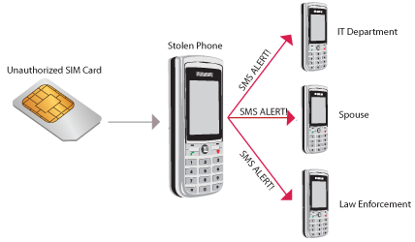
Fig 1.1 overview of the Application

1.2 Rules:
There are certain rules to be followed by the users while installing the devices –
- Once done with the installing it runs in background
- It supports only android users versions(4.0.4 to 5.0)

1.3 Existing System

Though the existing systems are computer based, they are very compact and limited to handle. Even if they are computer-based systems there are many flaws or drawbacks in these systems. Some of them are even being handled manually.

The following are the drawbacks of the existing manual System:
- Scope for redundancy
- Continuous data connection needed
- Time Delay
- No accuracy

1.4 Proposed System

The proposed system is using Android platform. Android environment is a freeware and is one of the effective platforms when it is used for all types of mobile OS applications. The robustness of the Android is too high as the internal software modules are not inter-related.

MERITS-
- Compatible with the latest Android OS

- Giving optimum access to the user.

2. SYSTEM ANALYSIS

This System Analysis is closely related to requirements analysis. It is also "an explicit formal inquiry carried out to help someone (referred to as the decision maker) identify a better course of action and make a better decision than he might otherwise have made." This step involves breaking down the system in different pieces to analyze the situation, analyzing project goals, breaking down what needs to be created and attempting to engage users so that definite requirements can be defined.

2.1 Functional Requirement Specification
The System after careful analysis has been identified to be present with the following modules.

A. Menu module
The menu module becomes an interface or a bridge between the user and the system. The menu module actually contains the graphical interface items

B. Processing Module:
This module maintains all the information to manage events done in the oragnization. This module is responsible for scheduling the events and deleting them.

2.2 Performance requirements

Performance is measured in terms of the output provided by the application. Requirement specification plays an important part in the analysis of a system. Only when the requirement specifications are properly given, it is possible to design a system, which will fit into required environment. It rests largely with the users of the existing system to give the requirement specifications because they are the people who finally use the system. This is because the requirements have to be known during the initial stages so that the system can be designed according to those requirements.
The requirement specification for any system can be broadly stated as given below:
- The system should be accurate
- The system should be better than the existing system
The existing system is completely dependent on the user to perform all the duties.
2.3 Software Requirements:
- Operating system: Android 4.0.4 to 5.0
- Android SDK
- Eclipse
2.4 Hardware Requirements:
A smart phone with at least,
- RAM 512MB
- Processor: 600MHZ
- GPS

3.SYSTEM DESIGN

Systems design is the process of defining the architecture, components, modules, interfaces, and data for a system to satisfy specified requirements. One could see it as the application of systems theory to product development. Object-oriented analysis and design methods are becoming the most widely used methods for computer systems design.

3.1 Modules

Module 1: Registration
- Module 1 describes what the user should do to use the app. User needs to register by entering his name, email id, password and friends phone number at first time.
- Next time user uses the app he needs to login by entering his name and password.

Module or Processing Module 2: Theft Protection
- Module 2 describes how the app informs user’s friend that phone was lost or stolen.
- When the thief uses the phone, automatically a message consists of IMEI, IMSI and LOCATION of phone will be sent to user’s friend.

3.2 UML Diagrams
UML Diagrams for our application are as follows:

3.2.1 Use Case Diagrams

Registration module

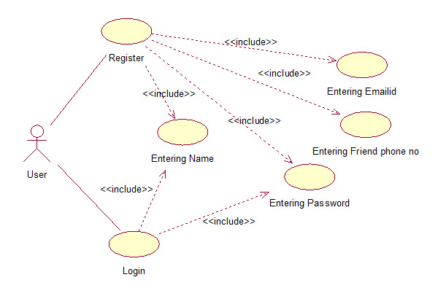
Fig 3.1 : usecase diagram for registration module

This UseCase Diagram depicts the functionality of registration and login . User needs to enter his name, password, email id and friend phone for SMS notifications at the first time. Next time user uses the app he needs to login by entering his name and password. Registration and login screens are provided by text fields, labels and buttons. Labels are a passive graphical user interface elements that convey a message or request the user to do something whereas the buttons are active graphical user interface elements which the user interacts for a action to be performed.

Theft Protection Module
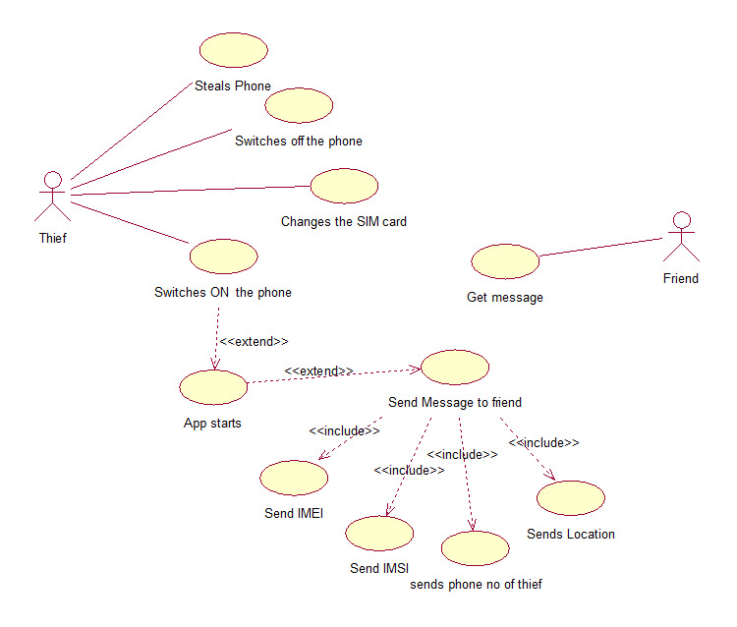
Fig 3.2 UseCase diagram for Theft Protection module

This UseCase Diagram depicts the functionality of the theft protection. It describes what the thief does when he steals the phone and how the message notified to user’s friend. When the thief changes the SIM card Get Back Droid will run in the background and sends the SMS consisting of IMEI, inserted SIM card IMSI number and Location of the lost device to the registered mobile number.

3.2.2 Sequence Diagram for Anti Theft

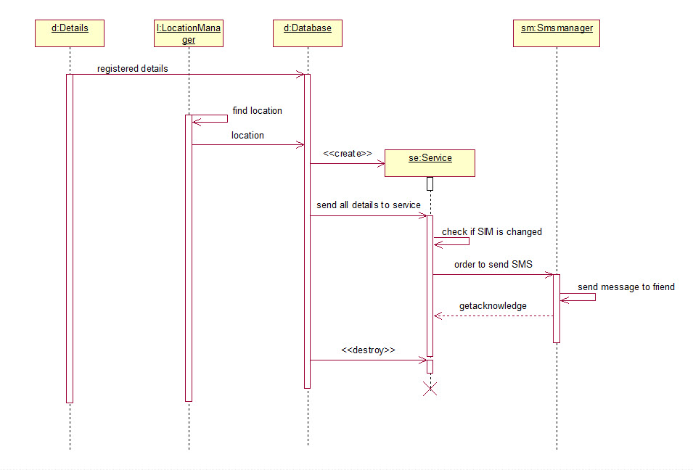

Fig 3.3 Sequence Diagram for Anti-Theft

Sequence Diagram for anti-theft shows how the application works in foreground and background. The registered details are stored in database and location will be frequently updated and stored in database. A service object is created and checks SIM card if it has chenged or not, when the SIM is changed it orders the smsmanger object to send the message and then the service object will be destroyed.

3.2.3 Collaboration Diagrams for Anti Theft

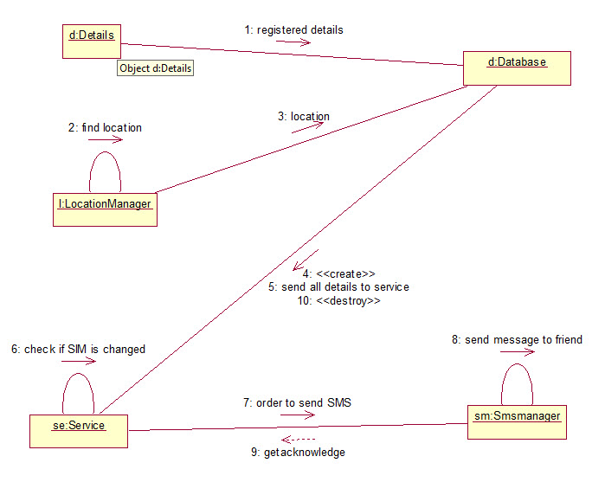

Fig 3.4 Anti-Theft collaboration diagram

4 . SYSTEM IMPLEMENTATION

4.1 Sample code

GetStarted class

package com.ibrahim.gbd;

import android.app.Activity;
import android.app.AlertDialog;
import android.content.DialogInterface;
import android.content.Intent;
import android.content.SharedPreferences;
import android.os.Bundle;
import android.view.Menu;
import android.view.MenuItem;
import android.view.View;
import android.widget.Button;

public class GetStarted extends Activity {

Button gst, about;
SharedPreferences sp1;

@Override
protected void onCreate(Bundle savedInstanceState) {
super.onCreate(savedInstanceState);
setContentView(R.layout.getstarted);
sp1 = getSharedPreferences("gbdfile1", 0);

gst = (Button) findViewById(R.id.gst);
about = (Button) findViewById(R.id.about);
gst.setOnClickListener(new View.OnClickListener() {

@Override
public void onClick(View v) {
// TODO Auto-generated method stub
SharedPreferences.Editor edi = sp1.edit();
edi.putInt("flag", 1);
edi.commit();
Intent i = new Intent("com.ibrahim.gbd.Register");
startActivity(i);
finish();
}
});

about.setOnClickListener(new View.OnClickListener() {

@Override
public void onClick(View v) {
// TODO Auto-generated method stub
Intent i = new Intent("com.ibrahim.gbd.About");
startActivity(i);
}
});
}

@Override
public boolean onCreateOptionsMenu(Menu menu) {
// Inflate the menu; this adds items to the action bar if it is present.
getMenuInflater().inflate(R.menu.main, menu);
return true;
}

@Override
public boolean onOptionsItemSelected(MenuItem item) {
// Handle action bar item clicks here. The action bar will
// automatically handle clicks on the Home/Up button, so long
// as you specify a parent activity in AndroidManifest.xml.
int id = item.getItemId();
if (id == R.id.action_settings) {
return true;
}
return super.onOptionsItemSelected(item);
}

@Override
public void onBackPressed() {
// TODO Auto-generated method stub
AlertDialog.Builder dialog = new AlertDialog.Builder(GetStarted.this);
dialog.setTitle("Exit");
dialog.setMessage("Do you really want to exit ?");

dialog.setPositiveButton("Ok", new DialogInterface.OnClickListener() {

public void onClick(DialogInterface dialog, int which) {
GetStarted.this.finish();

}
});

dialog.setNegativeButton("Cancel",
new DialogInterface.OnClickListener() {
public void onClick(DialogInterface dialog, int which) {
dialog.dismiss();
}
});
dialog.show();
}
}

GetLoaction class

package com.ibrahim.gbd;

import android.app.Service;
import android.content.Context;
import android.content.Intent;
import android.content.SharedPreferences;
import android.location.Location;
import android.location.LocationListener;
import android.location.LocationManager;
import android.os.Bundle;
import android.os.IBinder;
import android.widget.Toast;

public class GetLocation extends Service implements LocationListener {

Context mcontext;
Location l;
LocationManager lm;
double latitude, longitude;
boolean isGPSenabled, isNetworkenabled, cangetlocation;

public GetLocation(Context context) {
// TODO Auto-generated constructor stub
this.mcontext = context;

getLocation();
}

public Location getLocation() {
// TODO Auto-generated method stub
try{
lm = (LocationManager)mcontext.getSystemService(LOCATION_SERVICE);
isGPSenabled = lm.isProviderEnabled(lm.GPS_PROVIDER);
isNetworkenabled = lm.isProviderEnabled(lm.NETWORK_PROVIDER);

if(!isGPSenabled&&!isNetworkenabled){

}else{
this.cangetlocation = true;

if(isNetworkenabled){

lm.requestLocationUpdates(lm.NETWORK_PROVIDER, 60000, 10, this);
if(lm!=null){

l = lm.getLastKnownLocation(lm.NETWORK_PROVIDER);
if(l!=null){

latitude = l.getLatitude();
longitude = l.getLongitude();
}
}
}

if(isGPSenabled){
lm.requestLocationUpdates(lm.GPS_PROVIDER, 60000, 10, this);
if(lm!=null){
l = lm.getLastKnownLocation(lm.GPS_PROVIDER);
if(l!=null){
latitude =l.getLatitude();
longitude = l.getLongitude();
}
}
}
}

}catch(Exception e){
e.printStackTrace();
}
return l;
}

public double getLatitude(){
if(l!=null){
latitude = l.getLatitude();

}
return latitude;

}
public double getLongitude() {
if(l!=null){
longitude = l.getLongitude();
}
return longitude;
}

@Override
public void onLocationChanged(Location location) {
// TODO Auto-generated method stub

}

@Override
public void onStatusChanged(String provider, int status, Bundle extras) {
// TODO Auto-generated method stub

}

@Override
public void onProviderEnabled(String provider) {
// TODO Auto-generated method stub

}

@Override
public void onProviderDisabled(String provider) {
// TODO Auto-generated method stub

}

@Override
public IBinder onBind(Intent intent) {
// TODO Auto-generated method stub
return null;
}

}

RunningService class

package com.ibrahim.gbd;

import android.app.Service;
import android.content.Intent;
import android.content.SharedPreferences;
import android.os.IBinder;
import android.telephony.SmsManager;
import android.telephony.TelephonyManager;
import android.widget.Toast;

public class RunningService extends Service {

SharedPreferences sp2;
TelephonyManager tm;
int counter;

@Override
public void onCreate() {
// TODO Auto-generated method stub
super.onCreate();
sp2 = getSharedPreferences("gbdfile1", 0);
tm = (TelephonyManager) getSystemService(TELEPHONY_SERVICE);
counter = sp2.getInt("counter_key", 0);

}

@Override
public IBinder onBind(Intent intent) {
// TODO Auto-generated method stub
return null;
}

@Override
public void onStart(Intent intent, int startId) {
// TODO Auto-generated method stub
super.onStart(intent, startId);
}

@Override
public int onStartCommand(Intent intent, int flags, int startId) {
// TODO Auto-generated method stub
//Toast.makeText(getApplicationContext(), "Started", Toast.LENGTH_SHORT).show();
String one = sp2.getString("imsi1_key", "");
String two = sp2.getString("imsi2_key", "");
String three = tm.getSimSerialNumber();
if (one.equals(three) || two.equals(three)) {
//Toast.makeText(getApplicationContext(), "Sim did not change",Toast.LENGTH_SHORT).show();
} else {
if (counter < 4) {
sendMessage();

}
}

return START_STICKY;

}

public void sendMessage() {
// TODO Auto-generated method stub

GetLocation gl = new GetLocation(getApplicationContext());
Thread t = new Thread();
try {
t.sleep(10000);
} catch (InterruptedException e) {
// TODO Auto-generated catch block
e.printStackTrace();
}
String latt = Double.toString(gl.getLatitude());
String longg = Double.toString(gl.getLongitude());
String msgtext = "Your friend " + sp2.getString("uname_key", "")
+ "'s phone is lost.IMEI:" + tm.getDeviceId() + "\nIMSI:"
+ tm.getSimSerialNumber() + "\nLast fine location is.."
+ "\nLatitude:" + latt + "\nLongitude:" + longg;
String phoneno = sp2.getString("fphone_key", "");
SmsManager smsm = SmsManager.getDefault();
smsm.sendTextMessage(phoneno, null, msgtext, null, null);
counter++;
SharedPreferences.Editor edi = sp2.edit();
edi.putInt("counter_key", counter);
edi.commit();
//Toast.makeText(getApplicationContext(), "message sent",Toast.LENGTH_SHORT).show();
}
}

5. OUTPUT SCREENS

Output Screens of various functionalities in our application are shown over here along with the description.

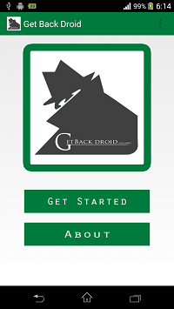

Fig 5.1 Starting screen for Get Back Droid

This is the starting screen of the application having the logo and two buttons named get started and about. When the user clicks on Get Started button it moves to registration screen and moves to about screen when he clicks on About button.

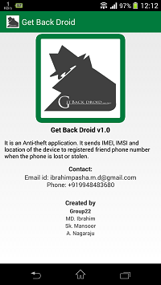

Fig 5.2 About

The above figure shows that when the user clicks on About button in the starting screen of the Get Back Droid application. It shows the version of the application and major operations that application performs. It will also show our group number and names.

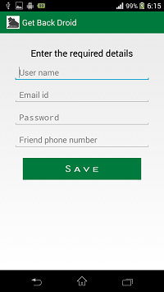

Fig 5.3 Registration

The above figure shows four text fields that are for entering user name, email id, password and friend phone number. There is also one save button. When user clicks on save button it checks that if user entered the proper details or not and if true then stores the all the details to its database.

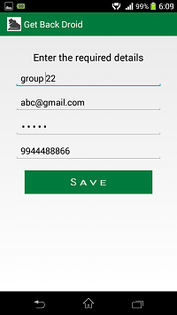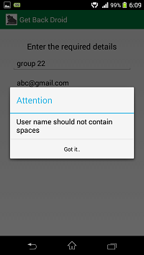

Fig 5.4 Enter Proper User Name

The above figures show when the user is registering he/she needs to enter the proper user name. User cannot fill the user name with spaces. If the user enters user name with space it will show a dialogue window saying “User name should not contain spaces” when the user presses on save button. Then the user will realize not to enter the user name with spaces.

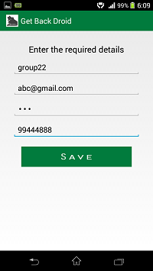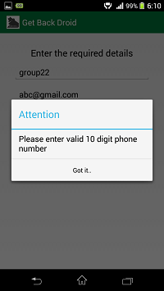

Fig 5.5 Enter Proper 10 digit phone number

The Above figure shows that when the user registering he/she needs to enter a proper 10 digit friend phone number. The user cannot enter the phone number which is less than the 10 digit number. If the user fails to give proper friend phone number then a dialogue window will appear saying that “Please enter a valid 10 digit phone number” when he/she presses on save button. Then user will know to give a proper 10 digit phone number and he can proceed for next step.

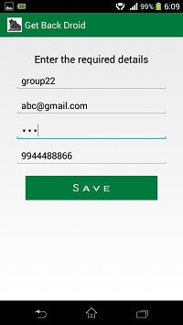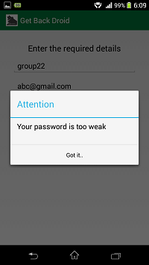

Fig 5.6 Weak Password

The above figures show when the user is registering he/she needs to enter the password with minimum length of 4 digits. The user cannot enter the password less than the 4 digits. If the entered password is less than 4 digits it will show a dialogue window saying “Your password is too weak” when the user presses the save button. Then user will know to enter the strong password and he can proceed for next step.

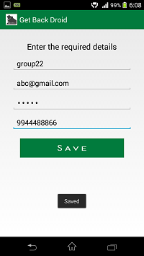

Fig 5.7 Saved Details

The above figure shows a popup Toast called “Saved” when the user enters all the details properly. When the user clicks on save button an Action Event will be generated and checks the text from text fields and if all the details are proper to accept then it will store the details in the database and shows a popup Toast called “Saved”.

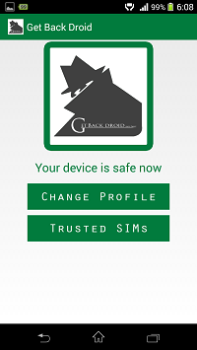

Fig 5.8 Status

The above figure show a status screen with logo of the application and two buttons called “Change Profile” and “Trusted SIMs”. There is also a text view with green color saying “Your device is safe now”. When the user clicks on Change Profile button it goes to a screen which is same as the registration screen. When the Trusted SIMs button is clicked it goes to a screen called Add IMSI where user can add the optional IMSI number.

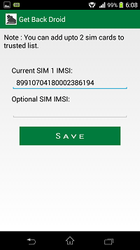

Fig 5.9 Add IMSI

The above figure shows two text fields where the user can add or change the IMSI (International Mobile Subscriber Identity) number of the SIM. When user clicks on save button internally the system will take the IMSI numbers from text fields and stores in the database.
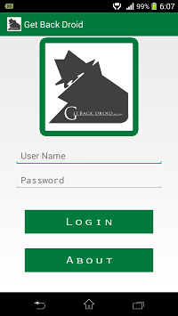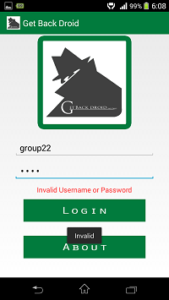

Fig 5.10 Login.

The above figure shows a login screen. After registering user may exit the application when he/she exits the application he/she needs to login the next time to open the application. The login screen contains two text fields and two buttons. After entering the user name and password user has to press the login button. When he/she presses on login button system will take the text from the two text fields and compares the entered credentials with the database. If the credentials are same as which are in the database it will goes to status screen otherwise it will show a popup toast called “Invalid” and a text view with “Invalid User name or password” in red color.

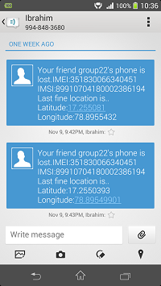

Fig 5.11 SMS notification to friend

The above figure shows a message is sent to friend’s phone. When the user’s device is lost or stolen someone or the thief will change the SIM card. When someone changes the SIM card and switches on the phone Get Back Droid will run in background and it will send the message consisting of device IMEI, inserted SIM card IMSI number and the location of the device by GPS (Global Positioning System) coordinates latitude and longitude. Friend can also know the inserted SIM number.

6. CONCLUSION AND FUTURE SCOPE

Conclusion

Get Back Droid is an Android operating systems based application which is compatible with android 4.0.4 and above. Anti theft feature is most important for every smart phone and Get Back Droid is one of its kind to provide this feature. It basically monitors the system modifications by running in the background, whenever SIM change noticed, identifies the primary user.

Future Scope

It is not possible to develop a system that makes all the requirements of the user. User requirements keep changing as the system is being used.
Some of the future enhancements that can be done to this system are:
- Can send photos of the thief through front camera.
- Device can be controlled by sending some SMS commands.
- Remotely manage the data in the device.
- Remotely lock the device.

BIBLIOGRAPHY

[1] www. developer.android.com

[2] www.stackoverflow.com

[3] www.androidhive.com

[4] www.tutorialspoint.com

[5] www.wikipedia.org

APPENDIX-A: Android Technology

About Android:
Android is a mobile operating system (OS) based on the Linux kernel and currently developed by Google. With a user interface based on direct manipulation, Android is designed primarily for touch screen mobile devices such as smart phones and tablet computers, with specialized user interfaces for televisions (Android TV), cars (Android Auto), and wrist watches (Android Wear). The OS uses touch inputs that loosely correspond to real-world actions, like swiping, tapping, pinching, and reverse pinching to manipulate on-screen objects, and a virtual keyboard. Despite being primarily designed for touch screen input, it also has been used in game consoles, digital cameras, regular PCs and other electronics.

User Interface:
Android's default user interface is based on direct manipulation, using touch inputs, that loosely correspond to real-world actions, like swiping, tapping, pinching, and reverse pinching to manipulate on-screen objects, and a virtual keyboard. The response to user input is designed to be immediate and provides a fluid touch interface, often using the vibration capabilities of the device to provide haptic feedback to the user. Internal hardware such as accelerometers, gyroscopes and proximity sensors are used by some applications to respond to additional user actions, for example adjusting the screen from portrait to landscape depending on how the device is oriented, or allowing the user to steer a vehicle in a racing game by rotating the device, simulating control of a steering wheel.
Android devices boot to the home screen, the primary navigation and information point on the device, which is similar to the desktop found on PCs. Android home screens are typically made up of app icons and widgets; app icons launch the associated app, whereas widgets display live, auto-updating content such as the weather forecast, the user's email inbox, or a news ticker directly on the home screen. A home screen may be made up of several pages that the user can swipe back and forth between, though Android's home screen interface is heavily customizable, allowing the user to adjust the look and feel of the device to their tastes. Third-party apps available on Google Play and other app stores can extensively re-theme the home screen, and even mimic the look of other operating systems, such as Windows Phone. Most manufacturers, and some wireless carriers, customize the look and feel of their Android devices to differentiate themselves from their competitors.
Present along the top of the screen is a status bar, showing information about the device and its connectivity. This status bar can be "pulled" down to reveal a notification screen where apps display important information or updates, such as a newly received email or SMS text, in a way that does not immediately interrupt or inconvenience the user. Notifications are persistent until read (by tapping, which opens the relevant app) or dismissed by sliding it off the screen. Beginning on Android 4.1, "expanded notifications" can display expanded details or additional functionality; for instance, a music player can display playback controls, and a "missed call" notification provides buttons for calling back or sending the caller an SMS message.
Android provides the ability to run applications which change the default launcher and hence the appearance and externally visible behavior of Android. These appearance changes include a multi-page dock or no dock, and many more changes to fundamental features of the user interface.

Applications:
Applications ("apps"), that extend the functionality of devices, are developed primarily in the Java programming language using the Android software development kit (SDK). The SDK includes a comprehensive set of development tools, including a debugger, software libraries, a handset emulator based on QEMU, documentation, sample code, and tutorials. The officially supported integrated development environment (IDE) is Eclipse using the Android Development Tools (ADT) plug-in. Other development tools are available, including a Native Development Kit for applications or extensions in C or C++, Google App Inventor, a visual environment for novice programmers, and various cross platform mobile web applications frameworks. In January 2014, Google unveiled an Apache Cordova–based framework for porting Chrome HTML 5 applications to Android, wrapped in a native application shell.
Android has a growing selection of third-party applications, which can be acquired by users by downloading and installing the application's APK file, or by downloading them using an application store program that allows users to install, update, and remove applications from their devices. Google Play Store is the primary application store installed on Android devices that comply with Google's compatibility requirements and license the Google Mobile Services software. Google Play Store allows users to browse, download and update applications published by Google and third-party developers; As of July 2013, there are more than one million applications available for Android in Play Store. As of May 2013, 48 billion applications have been installed from Google Play Store and in July 2013, 50 billion applications were installed. Some carriers offer direct carrier billing for Google Play application purchases, where the cost of the application is added to the user's monthly bill.

APPENDIX-B: UNIFIED MODELING LANGUAGE

The Unified Modeling Language (UML) is a general-purpose visual modeling language that is used to specify, visualize, construct, and document the artifacts of a software system. It captures decisions and understanding about systems that must be constructed. It is used to understand, design, browse, configure, maintain, and control information about such systems. It is intended for use with all development methods, lifecycle stages, application domains, and media. The modeling language is intended to unify past experience about modeling techniques and to incorporate current software best practices into a standard approach. UML includes semantic concepts, notation, and guidelines. It has static, dynamic, environmental, and organizational parts. It is intended to be supported by interactive visual modeling tools that have code generators and report writers. The UML specification does not define a standard process but is intended to be useful with an iterative development process. It is intended to support most existing object oriented development processes.

The UML captures information about the static structure and dynamic behavior of a system. A system is modeled as a collection of discrete objects that interact to perform work that ultimately benefits an outside user. The static structure defines the kinds of objects important to a system and to its implementation, as well as the relationships among the objects. The dynamic behavior defines the history of objects over time and the communications among objects to accomplish goals.

Modeling a system from several separate but related viewpoints permits it to be understood for different purposes.

The UML also contains organizational constructs for arranging models into packages that permit software teams to partition large systems into workable pieces, to understand and control dependencies among the packages, and to manage the versioning of model units in a complex development environment. It contains constructs for representing implementation decisions and for organizing run-time elements into components.

UML is not a programming language. Tools can provide code generators from UML into a variety of programming languages, as well as construct reverseengineered models from existing programs. The UML is not a highly formal language intended for theorem proving. There are a number of such languages, but they are not easy to understand or to use for most purposes. The UML is a general-purpose modeling language. For specialized domains, such as GUI layout, VLSI circuit design, or rule-based artificial intelligence, a more specialized tool with a special language might be appropriate. UML is a discrete modeling language.

It is not intended to model continuous systems such as those found in engineering
and physics. UML is intended to be a universal general-purpose modeling
language for discrete systems such as those made of software, firmware, or digital
logic.

